PERSONAL PROPERTY POLICY
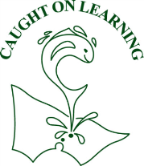
Eildon Primary School
No.3931
ABN 59 435 842 741
45 High St, EILDON, VIC, 3713.

Purpose
To explain Eildon Primary School’s policy in relation to personal property and to ensure that special or valuable items of personal property are not brought to school.

Scope
This policy applies to all school activities, including camps and excursions.

Policy
Eildon Primary School understands that staff and/or students may sometimes like to bring items of personal property to school.
The Department of Education and Training does not have insurance for personal property of staff, students and visitors. Eildon Primary School does not take responsibility for items of personal property that are lost, stolen or damaged at school or during school activities. Damage to personal property brought to school is the responsibility of the owner of that property.
Eildon Primary School encourages staff and students not to bring items of value to school, or to obtain appropriate insurance for such items.
If students bring items of value to school, they will be confiscated and stored securely at the School Office until the end of the day, when the items may be collected by the student and/or parent.

Review cycle
School Council Ratified: 26th March 2020
This policy will be reviewed in 2024

Principal Signature: …………………………………………………………………

School Council President: -----------------------------------------------

